HTHH Retrieval Package User’s Guide

March 3, 2026

Table of Contents
1. Introduction - 1 -
2. Structure of HTHH Package and How to Run - 2 -
3. Guidelines for inputs - 4 -
3.1 Vertical profiles of height, pressure, temperature, and ozone (H/P/T/O3) - 5 -
3.2 Radiance - 5 -
3.3 MIE Coefficients - 6 -
3.4 Absorption Cross Sections - 6 -
3.5 Configuration File - 7 -
4. Outputs - 9 -
4.1 Retrieval Output (DAT) - 10 -
4.2 Retrieval Log (LOG) - 11 -
4.3 Information for Retrieval Process (PLT) - 12 -
Appendix A. Source Code Detail - 15 -

Introduction
This document is a user guide for Hunga Tonga–Hunga Haʻapai (HTHH) package, which was developed in Spurr et al. (2026). The tool retrieves stratospheric aerosol optical depth (AOD) and aerosol peak height (Z_{p} > 20 km), and SO₂ column density by fitting the hyperspectral solar backscattered ultraviolet (BUV) radiation using on-line Vector Linearized Discrete Ordinate Radiative Transfer (VLIDORT) model version 2.8 combined with the polydisperse Mie calculations.
Although the authors in Spurr et al. (2026) used BUV radiance data from TROPOspheric Monitoring Instrument (TROPOMI) and ozone profiles from M2-SCREAM reanalysis data (MERRA-2 Stratospheric Composition Reanalysis of Aura Microwave Limb Sounder (MLS) produced by NASA's Global Modelling and Assimilation Office) for the Hunga-Tonga volcanic eruption on January 17, 2022. This package can also be applied to other volcanic eruption events using data from various hyperspectral instruments that cover ultraviolet wavelength regions (e.g., OMPS, OMI, and TOMS).
The Hunga tool was originally designed to support a 3-parameter retrieval of AOD, Z_{p}, and SO₂. Spurr et al. (2026) demonstrated that a reliable 2-parameter retrieval (AOD and Z_{p}) can be achieved using a 289–296 nm fitting window. Building on this work, the tool is being continuously updated to enable stable SO₂ retrievals by extending the fitting window. This also includes accounting for the effect of tropospheric clouds introduced by the extended window, by considering the impact of cloud albedo in both plume and background (Rayleigh) scenarios.
Therefore, this user guide is designed to assist users interested in aerosol and SO₂ retrievals during volcanic eruptions by providing a straightforward way to use the HTHH package. The guide includes a brief introduction to the HTHH retrieval algorithm, an overview of the package structure, and instructions on modifying the code or shell scripts for practical application. This information will be valuable for users intending to apply this package to other volcanic events or using data from different instruments.

Structure of HTHH Package and How to Run
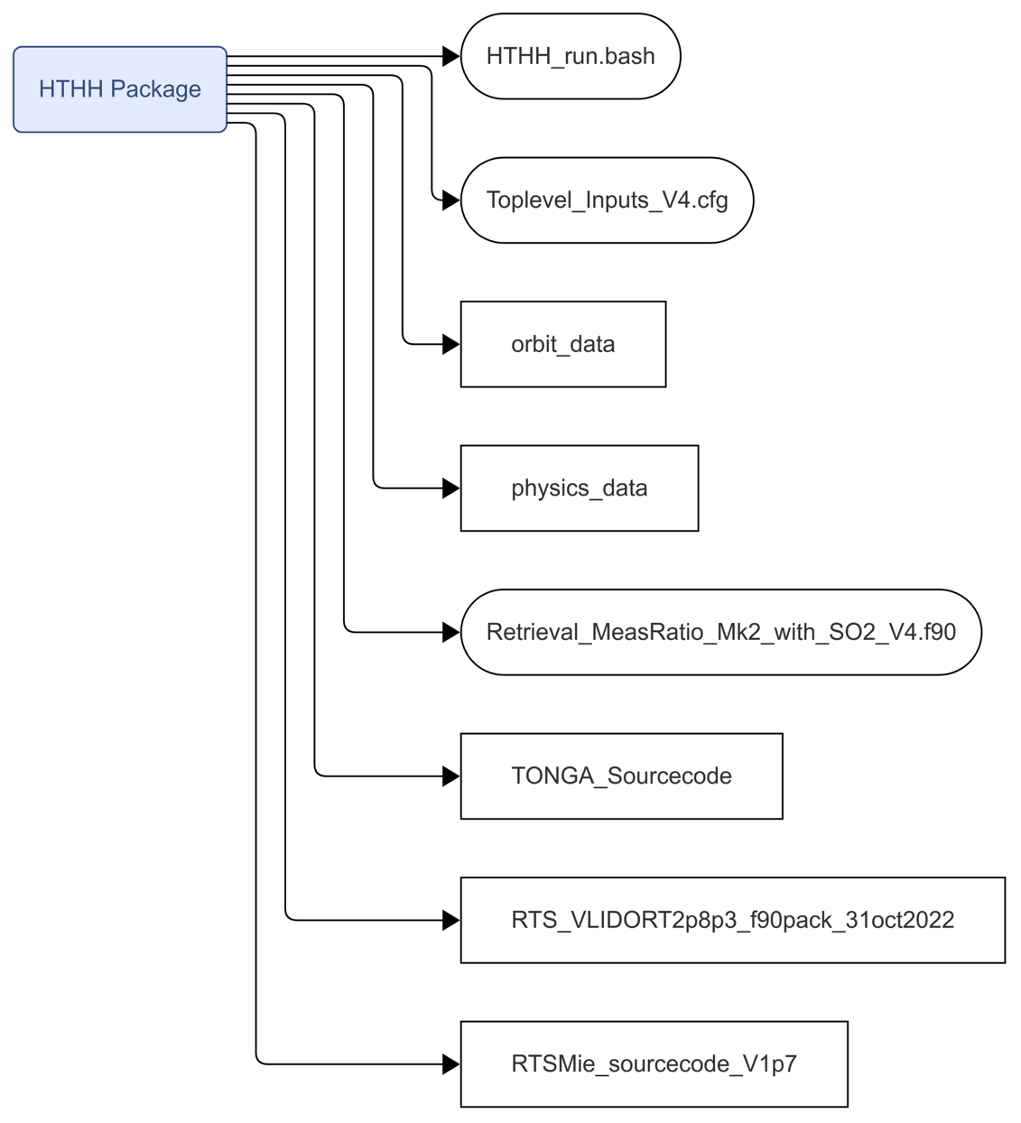
Figure 1. Structure of the HTHH Package
Each directory serves a specific purpose:
- HTHH_run.bash: Main shell script file to execute the HTHH package.
- Toplevel_Inputs_V4.cfg: Main configuration file for the package (see Section 3.5).
- orbit_data/physics_data: Directory containing input files (BUV radiance, pressure, temperature, ozone profiles, Mie parameters, absorption cross sections; see Section 3.1–3.4).
- Retrieval_MeasRatio_Mk2_with_SO2_V4.f90: Main Fortran retrieval code for the HTHH workflow.
- TONGA_Sourcecode: Directory containing HTHH internal source modules.
- RTS_VLIDORT2p8p3_f90pack_31oct2022: Directory containing VLIDORT radiative transfer model source code.
- RTSMie_sourcecode_V1p7: Directory containing Mie source code.

*Our package supports the OpenMP option. Please use the files marked with “_OMP” for running with OpenMP (e.g., HTHH_run_OMP.bash, Retrieval_MeasRatio_Mk2_with_SO2_V4_OMP.f90, and Toplevel_Inputs_V4_OMP.cfg).
*For a detailed visualization of the internal source code dependencies and the specific procedures, please refer to Appendix A. Source Code Detail.
To run the HTHH package, follow these steps:
- Set Up Configuration Files:
  - Open the Toplevel_Inputs_V4.cfg file in the package and adjust any necessary settings according to your desired output.
- Prepare Input Data:
  - Place the required input files in the orbit_data (atmospheric profiles and BUV radiance) and physical_data (absorption cross sections) directory. Ensure that files are formatted and named correctly as specified in the package instructions.
- Run the HTHH Package:
  - By running the HTHH_run.bash file, you can execute the HTHH tool.
  - MIE calculation: Set “T” for “Performs Mie calcs and dumps Mie results to file ONLY” in the configuration file. MIE parameters are calculated using the wavelength grid of the input BUV radiance data.
  - Main retrieval: Set “T” for “Uses Mie file data if TRUE” in the configuration file. For the retrieval of aerosols and SO2 (TBD), the calculated MIE parameters must be located in the orbit_data/mie directory.
- View the Output:
  - After running, the results will be saved in the main directory. Check the output files to verify that the data retrieval was successful. See Section 4 for the details of the output files.

Guidelines for inputs
The HTHH package requires specific input parameters, formatted and structured precisely. The input data type and format for the HTHH package can be summarized in Table 1. 'Mandatory change files' refer to files that need to be changed for each pixel during the retrieval of AOD, aerosol layer height, and SO₂. 'Fixed or customizable files' refer to files that can be adjusted or replaced if necessary. All files are in ASCII format, and the file names and the number of columns/lines in the files must be matched with the input data. Detailed information for each input data is described in Section 3.1 to 3.5.
Table 1. List of input data
 | Input | Directory | Notes
Mandatory Change Files | Atmospheric profiles*  (Section 3.1) | /orbit_data/atmos | Atmospheric pressure, temperature, and ozone profiles for background and plume pixels
 | Level 1 B data*  (Section 3.2) | /orbit_dara/rad | Measurement geometries, BUV radiance, and signal to noise ratio for background and plume pixels
 | Mie coefficients  (Section 3.3) | /orbit_data/mie | MIE parameters
Fixed or Customizable Files | Absorption cross sections  (Section 3.4) | /orbit_data/physics_data | Temperature-dependent SO₂ and O₃ absorption cross sections
 | Configure file  (Section 3.5) | / | Configuration for spectral fitting window, plume control, and aerosol scattering control
* Those files are required for both "background" and "volcanic plume" scenarios.

3.1 Vertical profiles of height, pressure, temperature, and ozone (H/P/T/O3)
- Directory: /orbit_data/atmos
- Filename:
  - Background pixel: make_063_HPTZ_22085_2071_03.dat
  - Plume pixel: make_063_HPTZ_22086_2071_03.dat
This file contains vertical profiles with 72 layers and 6 columns, including layer number, altitude, pressure, temperature, O₃ column density, and O₃ volume mixing ratio (VMR). These profiles can be sourced from the MLS M2-SCREAM product or other atmospheric data sources, as long as they follow this exact format.

3.2 Radiance
- Directory: /orbit_data/rad
- Filename:
  - Background pixel: TROPOMI_03_BD1_22085_2071_03, TROPOMI_21_BD2_22085_2071_03
  - Plime pixel: TROPOMI_03_BD1_22086_2071_03, TROPOMI_21_BD2_22086_2071_03
In Spurr et al. (2026), the HTHH tool was designed to read two separate TROPOMI radiance files — BD1 (~300 nm) and BD2 (above 300 nm) — to cover the extended fitting window from 289 nm to 310 nm. Therefore, the tool reads radiance information for both bands separately for background and plume pixels.
Each radiance file includes a two-line header followed by five columns:
Headers
- 1st Header: Number of wavelengths
- 2nd Header: Coordinates and measurement geometries, including latitude, longitude, Solar Zenith Angle (SZA), Viewing Zenith Angle (VZA), Solar Azimuth Angle (SAA), and Viewing Azimuth Angle (VAA).
Columns
- 1st column: Wavelength
- 2nd column: BUV radiance
- 3rd column: Spectral signal-to-noise ratio (used as error covariance matrix; see Spurr et al., 2026)

3.3 MIE Coefficients
- Directory: /orbit_data/mie
- Filename: MIE_22086_2071_03_TROPOMI_2Band
The MIE coefficients are essential for the main retrieval process and are generated by executing the HTHH_run.bash file. This step must be completed prior to running the main retrieval code. The MIE coefficients are specifically calculated based on the wavelength details from the Level 1B radiance data.

3.4 Absorption Cross Sections
- Directory: /physics_data
- Files:
  - SO₂: Bogumil_so2_xsec_tmp_270_400nm.dat
  - O₃: o3abs_brion_195_660_vacfinal.dat
The HTHH package allows for the use of customized absorption cross-sections. If the users want to use their own user-defined cross-section data, the files must retain the above names to ensure compatibility. This is because the package is configured to read only from files with specific names for absorption cross sections.

3.5 Configuration File
- Directory: /
- Filename: Toplevel_Inputs_V4.cfg
This configuration file allows users to customize various retrieval settings to make the HTHH package useful for different atmospheric scenarios and volcanic events. By adjusting these settings, users can adapt the retrieval process for various environmental conditions. Users can change main settings include the fitting window, plume shape, and aerosol properties, which help the retrieval process match specific needs in the analysis.
For example, adjusting the fitting window helps users focus on the desired wavelength range, allowing them to concentrate on the most relevant wavelengths and reflect the characteristics of the L1B data being used. Additionally, changing the plume shape settings can better capture the structure of volcanic plumes in different conditions. Users can also set aerosol properties that match the expected types of aerosols. By default, the aerosol properties in this file are based on scattering aerosols (sulfate) measured from AERONET at the Lucinda site on Jan 17, 2022, but users can adjust these settings as needed to reflect other environments.
Table 2. Details of Configuration Parameters for the HTHH Package
Category | Parameter
Parallel Computing Control  (OpenMP only) | Number of processor cores  Retrieval & Forward model timing
Retrieval Scene Pre-screening | Wavelength Index (lower limit) for pre-screening  Wavelength index (upper limit) for pre-screening  Radiance Ratio threshold for pre-screening
RT Control | Number of stokes vector elements  Half of the RT streams  Find layer control for FOCORR_OUTGOING in VLIDORT  No multiple scatters in VLIDORT
Wavelength Limits | Lower wavelength limit for the fitting window [nm]  Upper wavelength limit for the fitting window [nm]
Plume Control | Upper limit of plume [km]  Lower limit of plume [km]  Halfwidth half maximum of plume [km]  Flag for retrieving plume fwhm  Reference wavelength [nm]  First-guess value of AOD  First-guess value of Peak Height [km]
SO₂ Control | Flag for including SO₂  Source file of SO₂ cross section  First-guess value of total column SO₂ (DU)  Flag for retrieving SO₂
Aerosol Scattering Control  (parameterized values for aerosol; default: sulfate) | Flag for retrieving refractive index (real part) (TBD)  Flag for retrieving refractive index (imaginary part) (TBD)  Bimodal number fraction  Fine mode refractive index (real part)  Fine mode refractive index (imaginary part)  Fine mode radius  Fine mode shape parameter  Coarse mode refractive index (real part)  Coarse mode refractive index (imaginary part)  Coarse mode radius  Coarse mode shape parameter  Flag for doing initial Mie calculations  (Performs desired Mie calculations and dumps Mie results to file only)  Flag for use initial Mie calculations  (Uses dumped Mie data directly if TRUE)

Outputs
The output from running the HTHH package is saved in the main directory. The final retrieved values for AOD, Hgt, and SO₂ column density are saved in the DAT file, while retrieval logs are stored in the LOG file, and the PLT file contains wavelength-specific fitting results and errors. Detailed descriptions are provided in Sections 5.1 through 5.3.
The output file name is determined according to user-defined settings in the configuration file, including the number of retrieval parameters (par), fine mode fraction (Bf), fine mode radius (Rg), fine mode shape parameter (Sg), the real (Nr) and imaginary (Ni) parts of the refractive index, the lower (WLo) and upper (WHi) limits of the fitting window, and the flag for including SO₂ (IncSO₂). For example:
- 2-parameter retrieval RetRes_2par_AOD_PKHT_{Bf}_{Rg}_{Sg}_{Nr}_{Ni}_{WLo}_{WHi}_{IncSO2}_22086_2071_03_RType5.{DAT, LOG, or PLT}_nt4
- 3-parameter retrieval RetRes_3par_AOD_PKHT_SO2_{Bf}_{Rg}_{Sg}_{Nr}_{Ni}_{WLo}_{WHi}_{IncSO2}_22086_2071_03_RType5.{DAT, LOG, or PLT}_nt4

4.1 Retrieval Output (DAT)
- Filename (3-paramter retrieval example): RetRes_3par_AOD_PKHT_SO2_{Bf}_{Rg}_{Sg}_{Nr}_{Ni}_{WLo}_{WHi}_{IncSO2}_22086_2071_03_RType5.DAT_nt4
The first line of the DAT file contains the chi-square (CHISQ) value, ALAMBDA, final AOD, Hgt, and SO₂ values along with their respective errors from the last iteration, where CHISQ is minimized after multiple iterations in the HTHH package. The second line is blank, and lines 3 to 5 present the cross-correlation matrix among AOD, Hgt, and SO₂ (Figure 2).
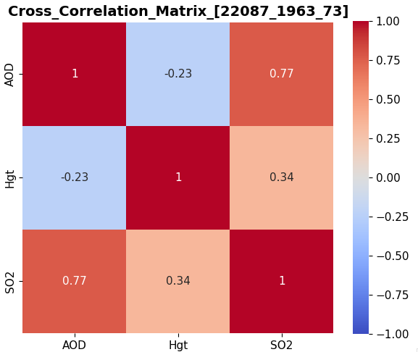
Figure 2. Cross Correlation Matrix from 3-parameter retrieval (NOrbit: 22087; NTime: 1963; NScan: 73)

4.2 Retrieval Log (LOG)
- Filename (3-paramter retrieval example): RetRes_3par_AOD_PKHT_SO2_{Bf}_{Rg}_{Sg}_{Nr}_{Ni}_{WLo}_{WHi}_{IncSO2}_22086_2071_03_RType5.LOG_nt4
The LOG file records the changes in CHISQ across each iteration until convergence, as well as the values of CHISQ, ALAMBDA, retrieved AOD, Hgt, and SO₂ column density for each iteration (Figure 3).
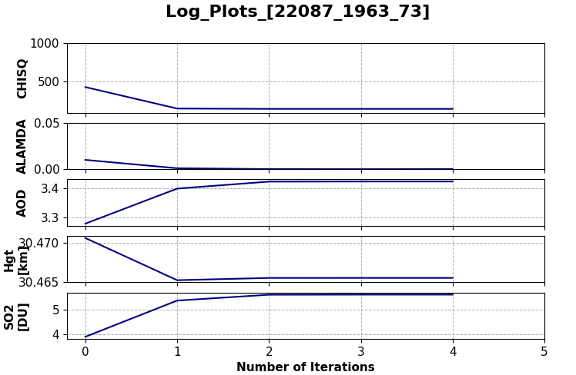
Figure 3. Log Plots for CHISQ, Alambda, AOD, Hgt, and SO₂ from 3-parameter retrieval (NOrbit: 22087; NTime: 1963; NScan: 73)

4.3 Information for Retrieval Process (PLT)
- Filename (3-paramter retrieval example): RetRes_3par_AOD_PKHT_SO2_{Bf}_{Rg}_{Sg}_{Nr}_{Ni}_{WLo}_{WHi}_{IncSO2}_22086_2071_03_RType5.PLT_nt4
The PLT file includes details from the final converged iteration, showing measured radiance, simulated radiance, Jacobians for each retrieved parameter, radiance errors, and forward model errors (Figure 4). Additionally, the tool provides SO₂ air mass factors (AMFs) for 3-parameter retrieval across the fitting window. The labels for each column retrieval are as follows:
3-parameter retrieval (AOD, Hgt, and SO₂)
  - Column 1: Wavelength
  - Column 2: Measured radiance ratio
  - Column 3: Simulated radiance ratio
  - Columns 4-6: Simulated Jacobian for each parameter (AOD, Hgt, SO₂)
  - Column 7: Standard deviation of radiance ratio noise (sigs_orig)
  - Column 8: Standard deviation of forward model error (sigF)
  - Column 9: Combined error (sigs_orig + sigF)
  - Column 10: Forward model error (epsF)
  - Column 11: SO₂ AMF
2-parameter retrieval (AOD and Hgt)
  - Column 1: Wavelength
  - Column 2: Measured radiance ratio
  - Column 3: Simulated radiance ratio
  - Columns 4-5: Simulated Jacobian for each parameter (AOD and Hgt)
  - Column 6: Standard deviation of radiance ratio noise (sigs_orig)
  - Column 7: Standard deviation of forward model error (sigF)
  - Column 8: Combined error (sigs_orig + sigF)
  - Column 9: Forward model error (epsF)

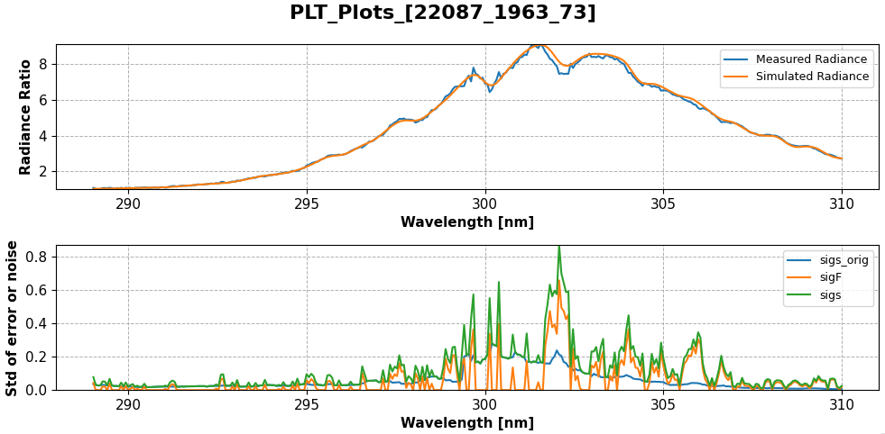
Figure 4. PLT plots for radiance ratios and errors from 3-parameter retrieval (NOrbit: 22087; NTime: 1963; NScan: 73)

References
Spurr, R. J. D., Christi, M., Krotkov, N. A., Choi, W.-E., Carn, S., Li, C., Kramarova, N., Haffner, D., Yang, E.-S., Gorkavyi, N., Vasilkov, A., Wargan, K., Torres, O., Loyola, D., Di Pede, S., Pepijn Veefkind, J., Case, P., Schroeder, T., and Bhartia, P. K.: Solar Backscatter Ultraviolet (BUV) retrievals of mid-stratospheric aerosols from the 2022 Hunga Eruption, Atmos. Meas. Tech., 19, 993–1021, https://doi.org/10.5194/amt-19-993-2026, 2026.

Appendix A. Source Code Detail
This appendix provides a comprehensive map of the internal functional structure of the HTHH package. Figure A1 illustrates the logical flow and dependencies between the main retrieval codes along with a list of key subroutines and functions defined within each file.
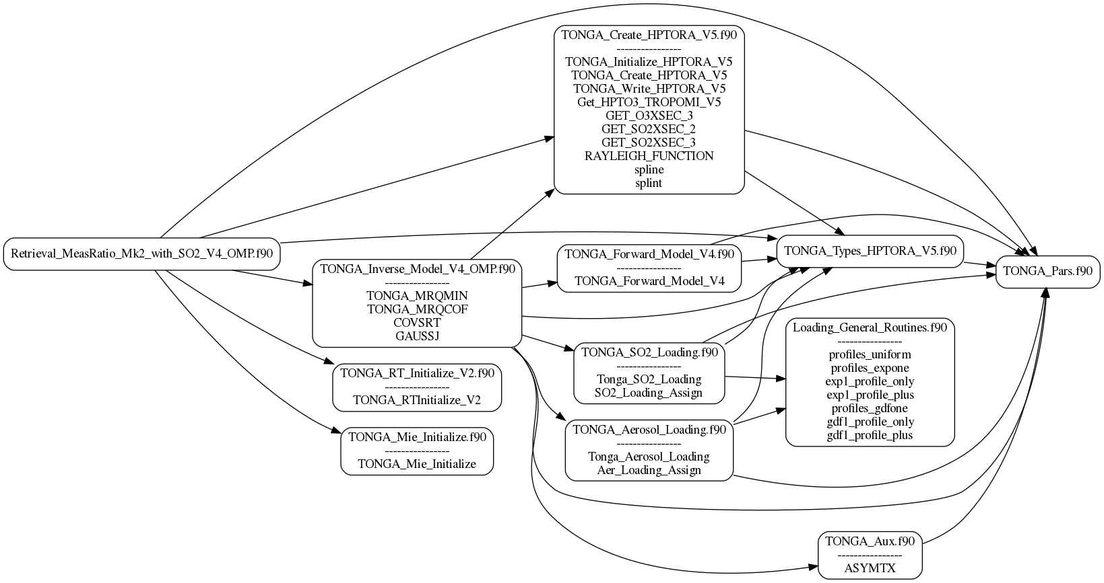
Figure A1. Detailed internal dependency and procedure mapping for the HTHH package (OpenMP version).

